
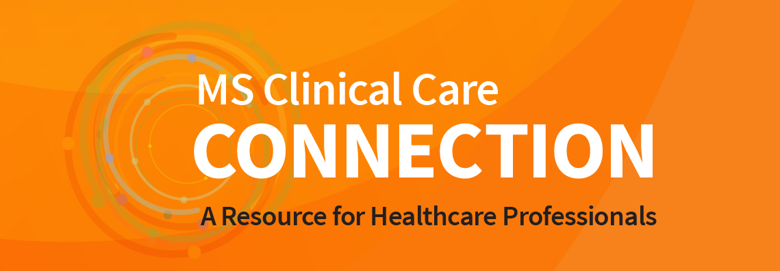

News for Health Professionals

Sexual Function and Satisfaction May be Low and Linked to Other Symptoms in People Living with MS
A new study, “Sexual Problems in MS: Sex Differences and Their Impact on Quality of Life” conducted by researchers at Brigham & Women’s Hospital has found that people with MS and minimal disability had low levels of sexual function and satisfaction. Decreases in sexual function and satisfaction over time were linked to increased disability and increased symptoms such as fatigue and depression. This study highlights the importance of discussing sexual problems with your patients, even early in the course of MS before experiencing physical disability.
Read the Study

Professional Education

4 Ways to Connect with the MS Society at CMSC
Symposium: Changing the MS Journey
Wednesday, May 31, 8:00 a.m. MST Symposium Registration
Learn about innovative programs and resources available through the National MS Society designed to support individuals through the changing journey of MS. Discover the Society’s updated online presence, expanded resources and strategic partnerships. Understand the progress the Society is making in the areas of diversity, equity, inclusion, health literacy and health equity.
Breakfast: Revisiting the Clinical Course Descriptors of MS
Thursday, June 1, 7:00 a.m. MST Breakfast Registration
Join Dr. Ruth Ann Marrie – winner of the 2022 Barancik Prize for Innovation in MS research - for a discussion on an international initiative to revisit the clinical course descriptors of MS. As past chair of the International Advisory Committee on Clinical Trials in Multiple Sclerosis, Dr. Marrie will provide an overview of the committee’s efforts to develop a mechanism-driven framework for describing the course of multiple sclerosis. You will have the opportunity to provide your perspective on this work for patients and healthcare providers.
Visit our exhibit table: #701
pick up literature and speak with Society staff about resources.
Visit our Posters
We have five posters featuring our programs offered to individuals affected by MS and healthcare providers. Meet with Society staff and learn more about the impact of these educational opportunities.

University of Washington’s 2023 Virtual MS Summit
Saturday, May 13, 11:00 a.m. - 4:00 p.m. EST
FREE Webinar | $25 for CE certificate
A virtual collaborative CME program from a panel of MS specialists in the Pacific Northwest, this summit welcomes neurologists, physiatrists, nurse practitioners and physician assistants in search of answers to complex questions on multiple sclerosis. Other disciplines are welcome. Sponsored by the University of Washington Medicine Neurosciences Institute and endorsed by the National MS Society.
Register Now with UW Medicine

Mellen Center Update in Multiple Sclerosis (Hybrid Meeting)
Friday, June 23, 7:00 a.m. - 4:00 p.m. EST
Featuring Dr. Darin Okuda from the University of Texas Southwestern Medical Center as the keynote speaker, this one-day, hybrid event will focus on three tracks designed to appeal to a wide range of interests. This update is intended for healthcare practitioners engaged in the care of patients with MS and related disorders. CME opportunities available.
Register Now with Cleveland Clinic

Resources for Your Patients

2023 Black MS Experience Summit
June 14-15, 2023, 1:00 p.m. - 4:00 p.m. EST Both Days
We are excited to continue our commitment to the Black MS community and help amplify voices, build connections, and support those affected by MS. This year’s virtual summit is focused on Resist Invisibility and Embrace Identity, will feature dynamic stories and speakers who will address invisibility and create a safe space to share stories and connect through common experiences.
Register Now

Ask an MS Expert Webinar Series
[Pregúntale a un Experto - Un seminario ofrecido en español por internet]
The Ask an MS Expert series focuses on a topic related to the MS community and provides the opportunity to ask questions live. Programs are also recorded so that they may be viewed as schedules allow. Society website, Facebook and YouTube.
- English: Every Friday 1:00 p.m. EST
- Spanish: Third Wednesday 7:00 p.m. EST
- Veterans: Four times a year 1:00 p.m. EST
Series Details

  
     |  |  |  |  |  | 
    DONATE NOW

National MS Society | Legal Notice/Privacy Policy | Email Preferences | Unsubscribe
The National Multiple Sclerosis Society | 733 3rd Ave., New York, NY 10017 US
Contact us at nationalMSsociety.org or 1-800-344-4867

